**AWS FACE RECOGNITION PROJECT**

**SUDINA K R**

**1JT16IS054**

**JYOTHY INSTITUTE OF TECHNOLOGY**

**BANGALORE**

**SCREENSHOTS**

**DASHBORDS:**

1. **AWS login screen with username**

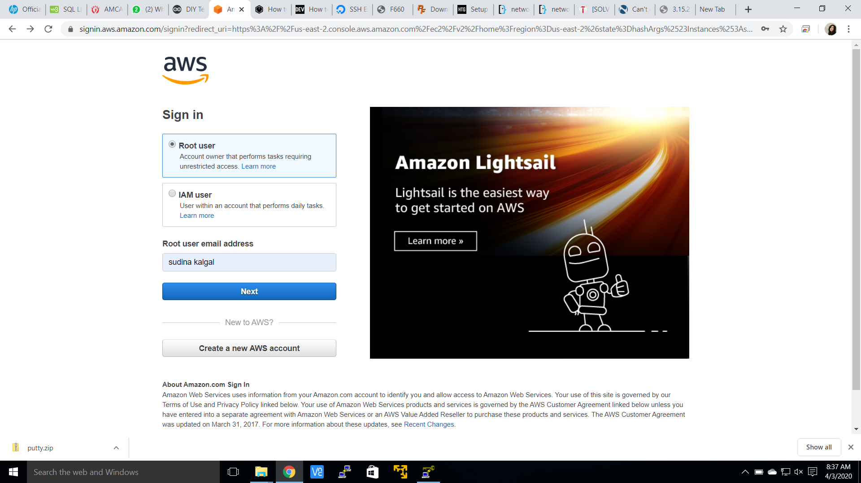

1. **EC2 dashboards**

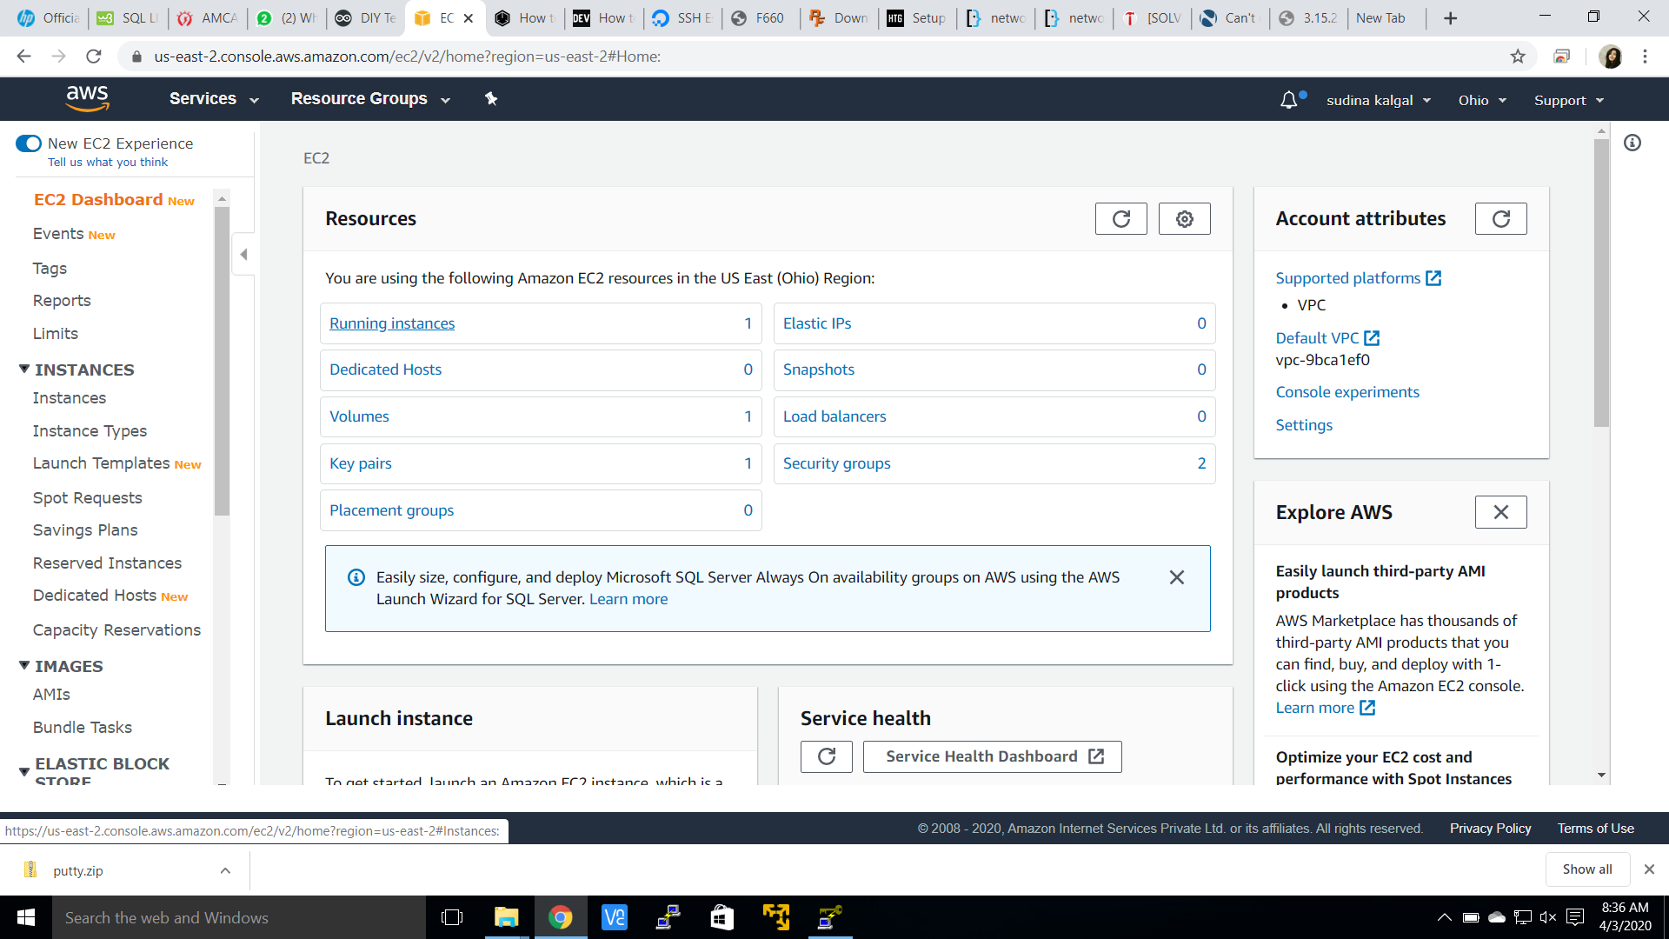

1. **S3 dashboards**

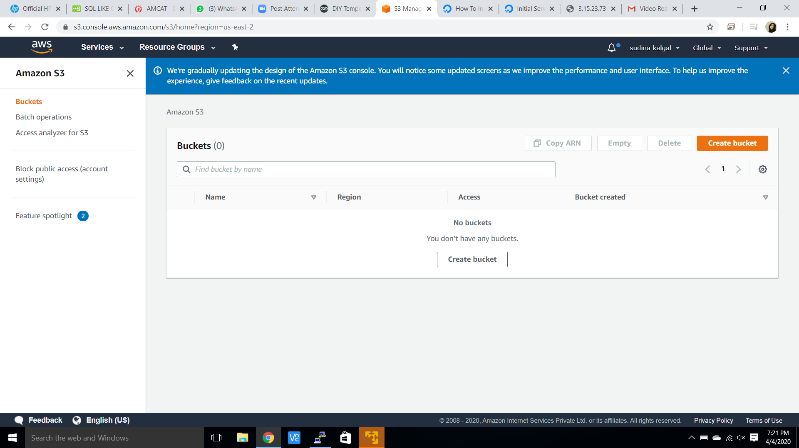

1. **Rekognition dashboard**

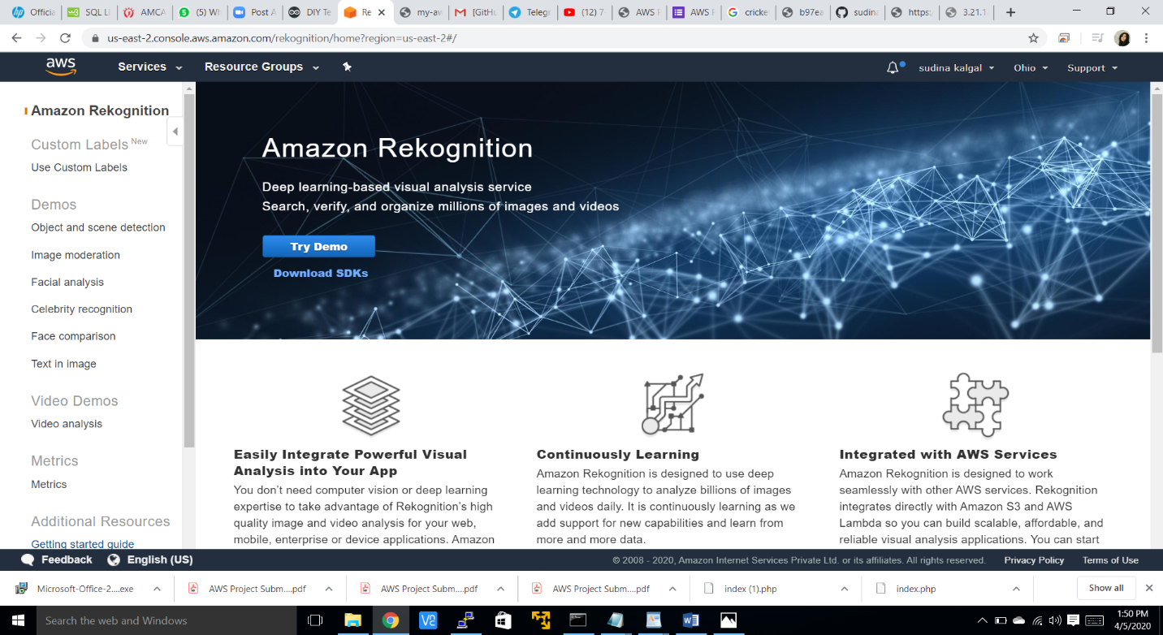

**EC2 SCREENSHOTS:**

1. **Choosing an AMI**

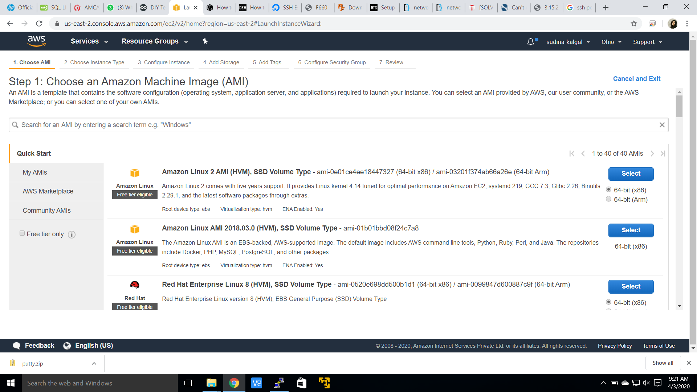

1. **Choosing an instance type**

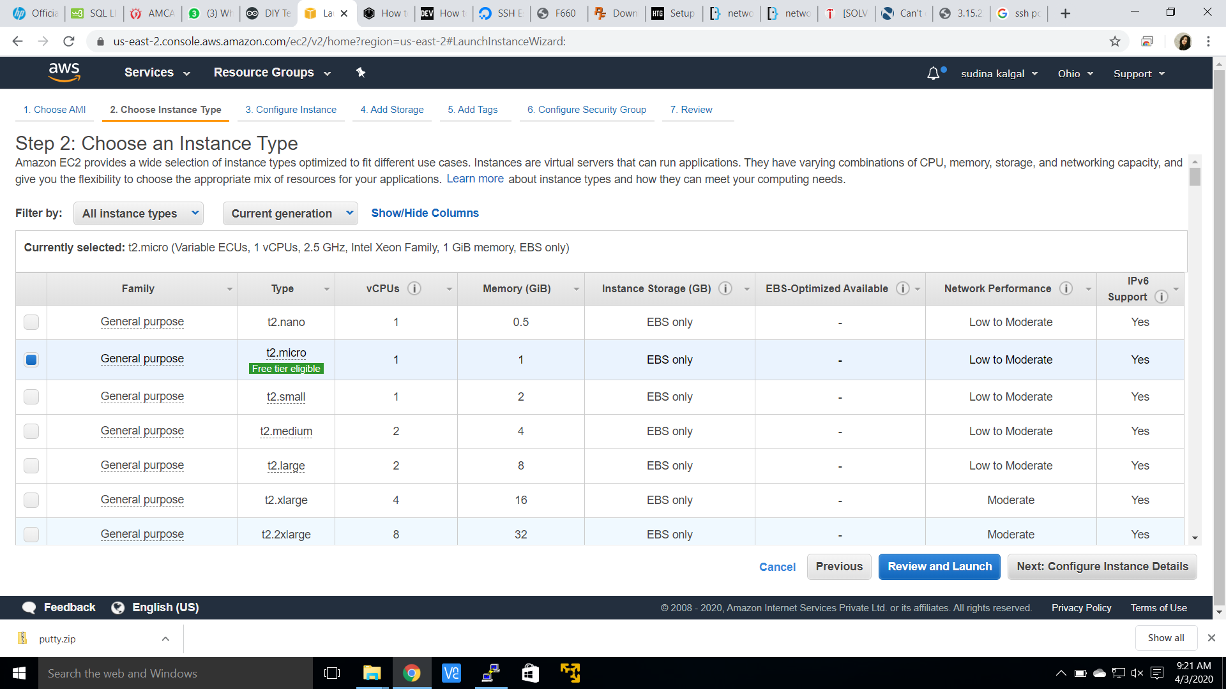

1. **Adding storage**

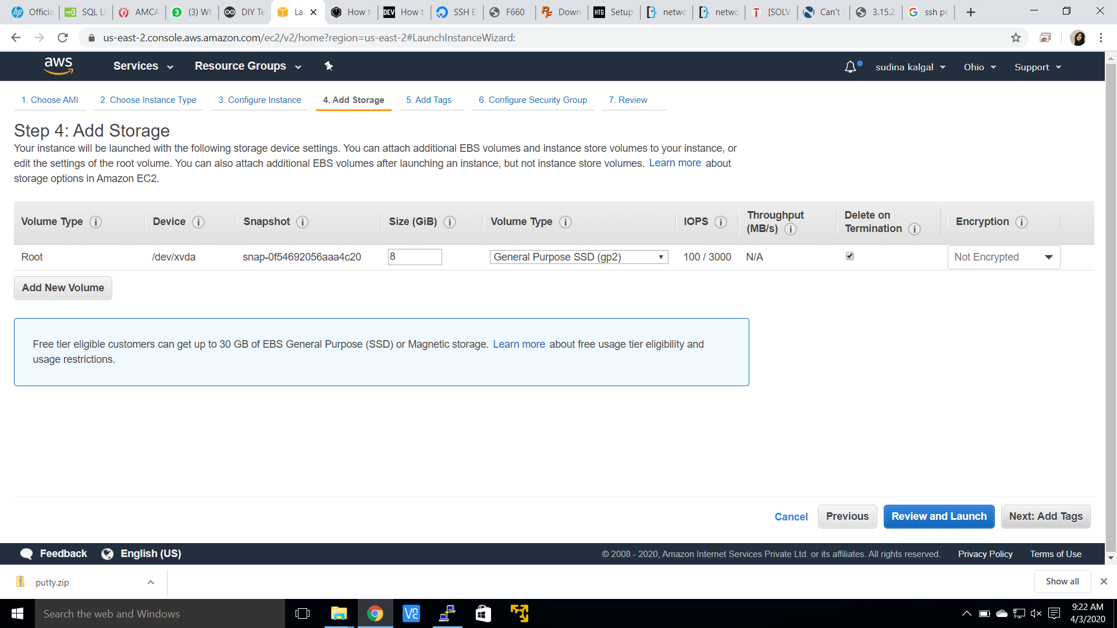

1. **Configure security group**

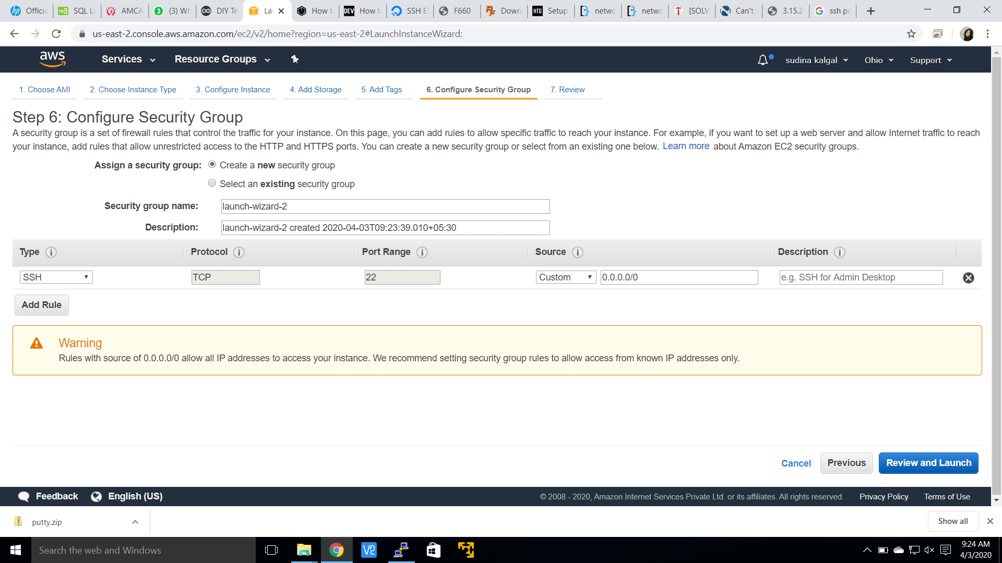

1. **Key pair download**

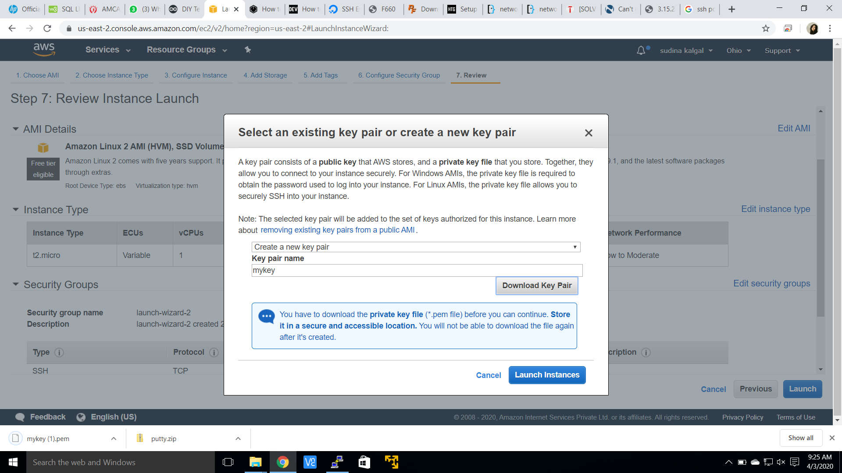

1. **PuTTYgen conversion from pem to ppk**

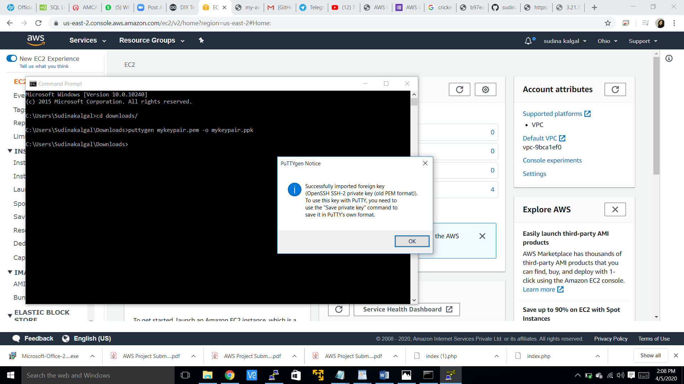

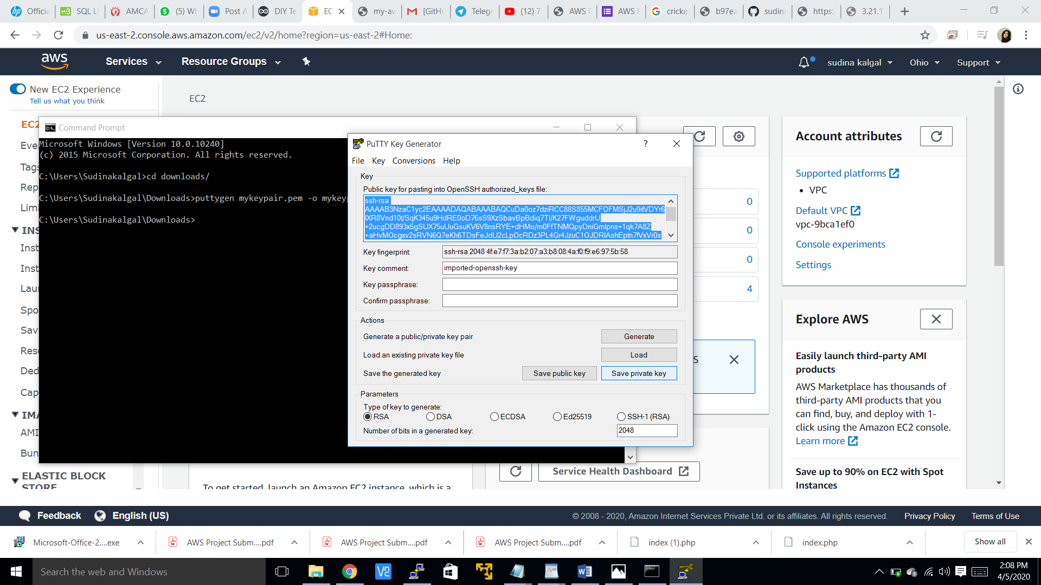

1. **Logged in EC2 black screen**

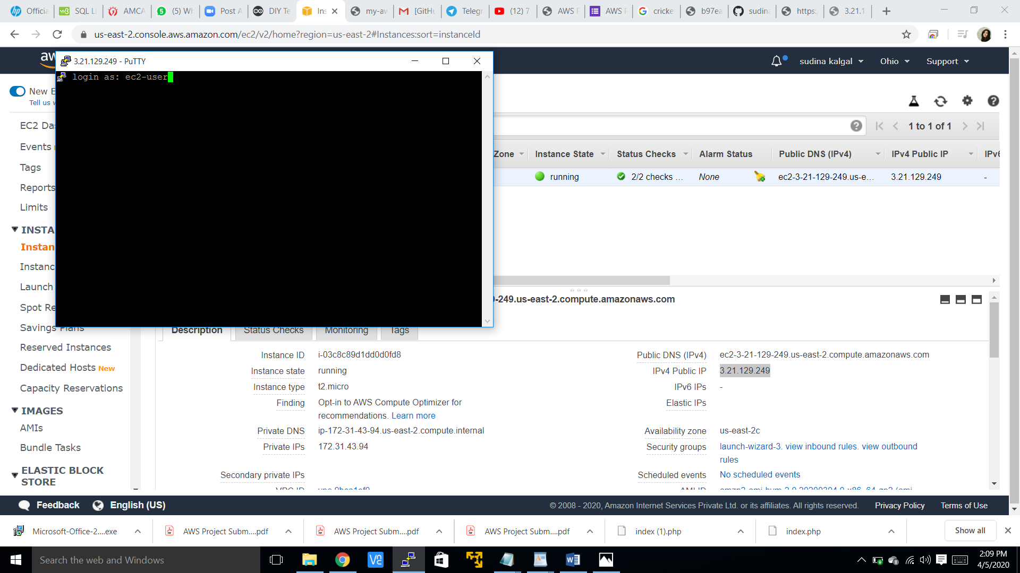

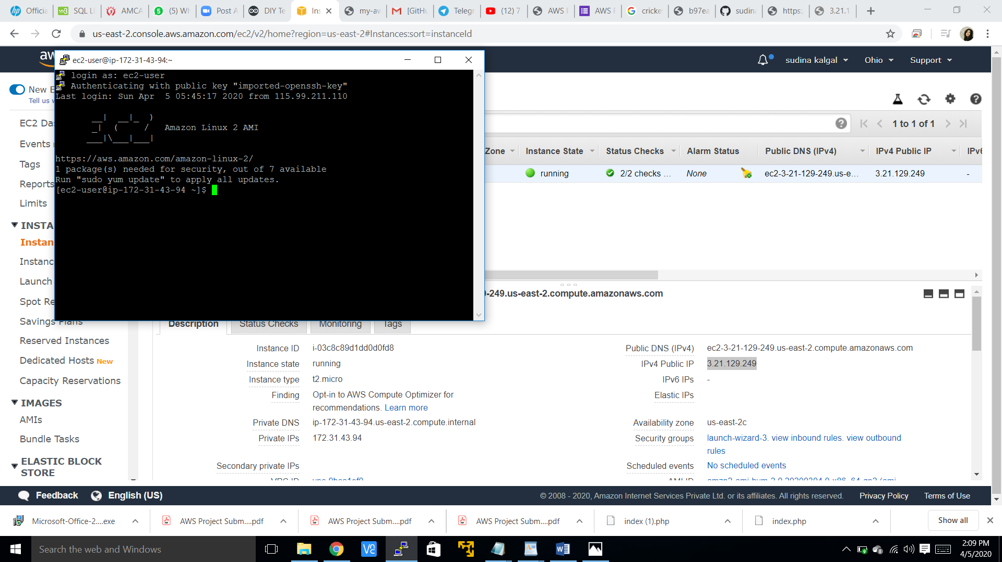

**S3 SCREENSHOTS:**

1. **Creating bucket**

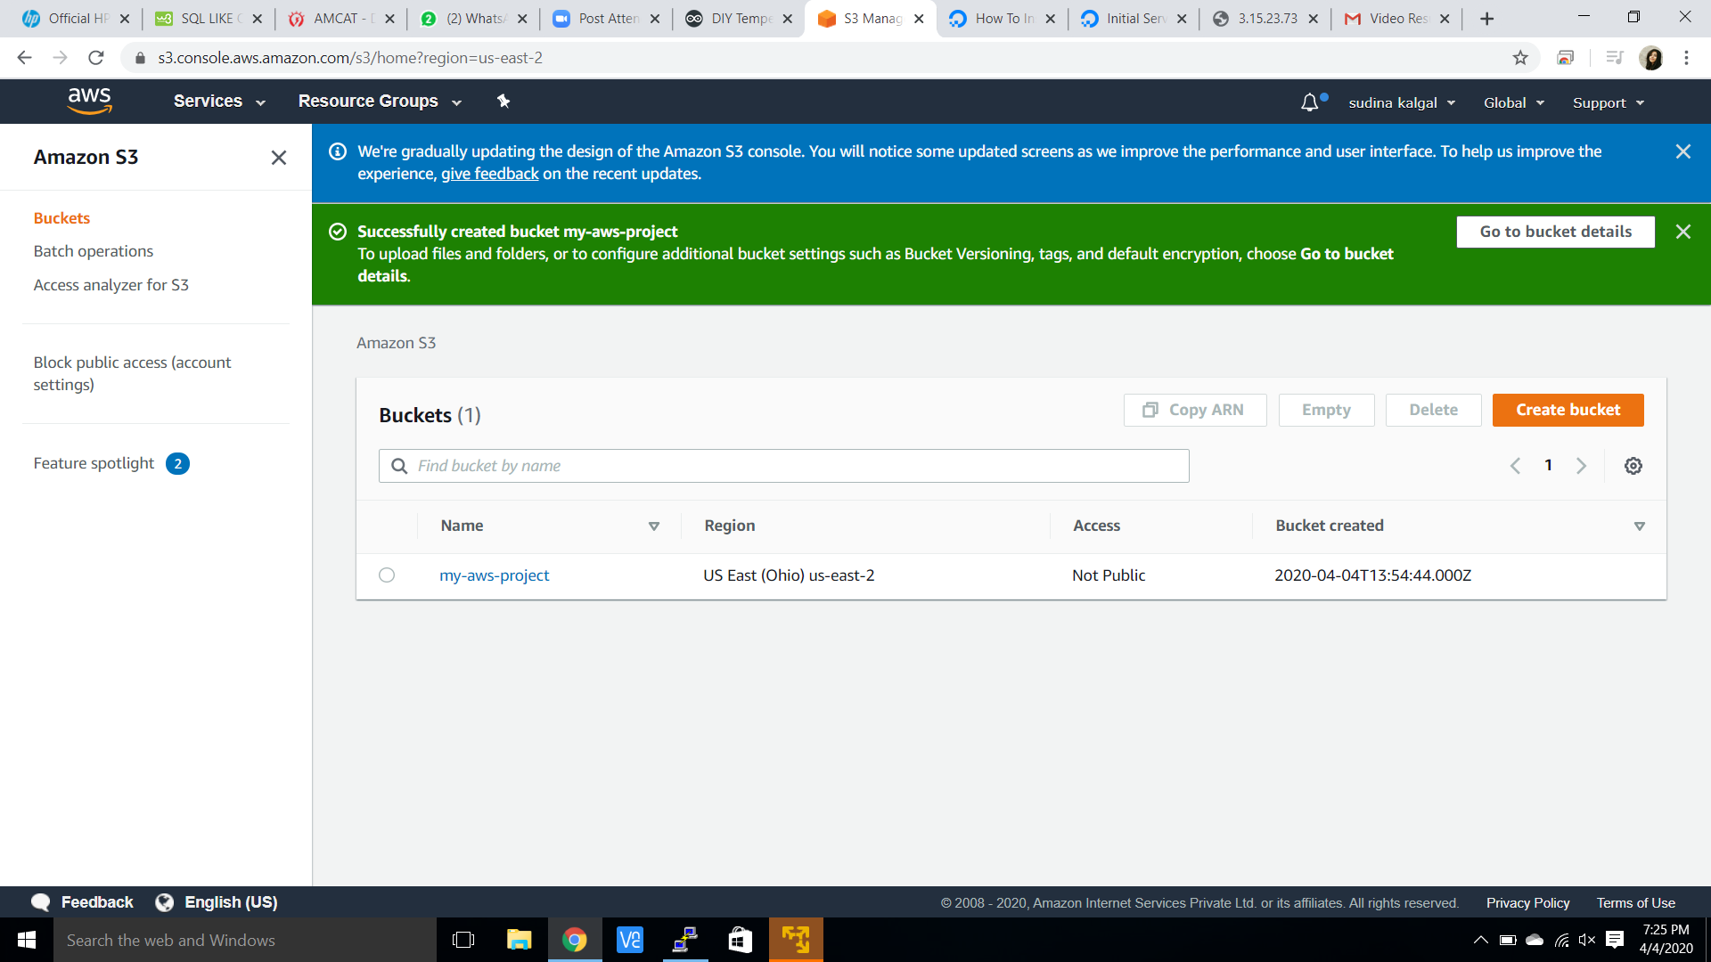

1. **Uploading an object**

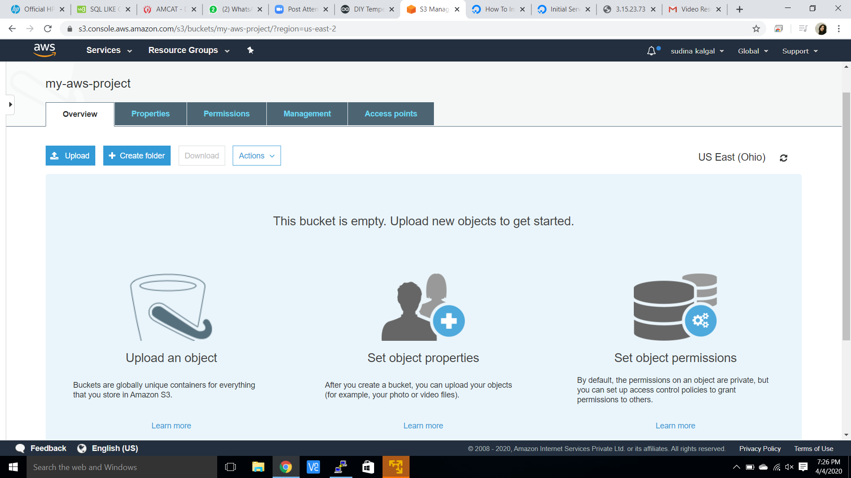

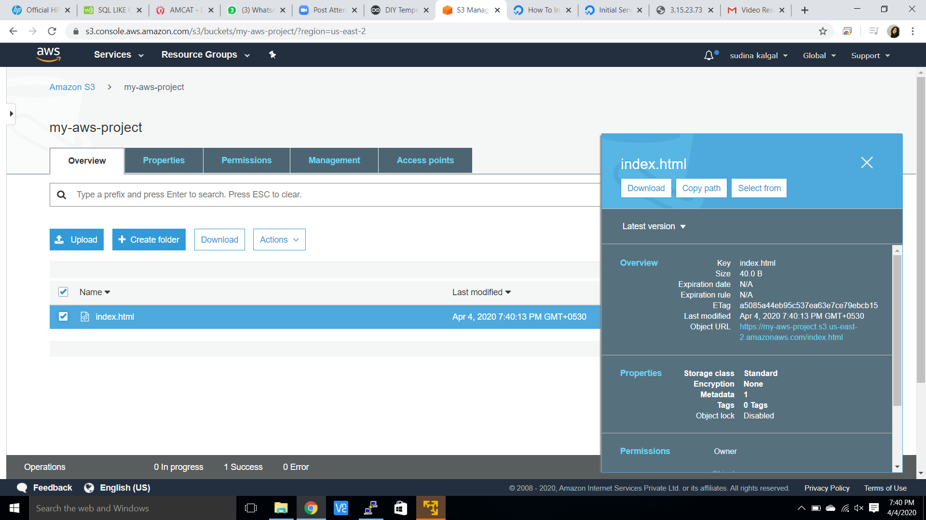

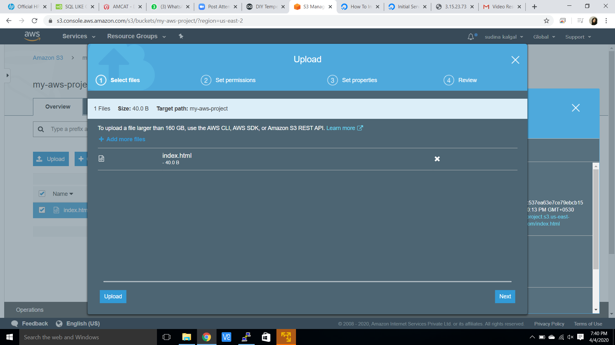

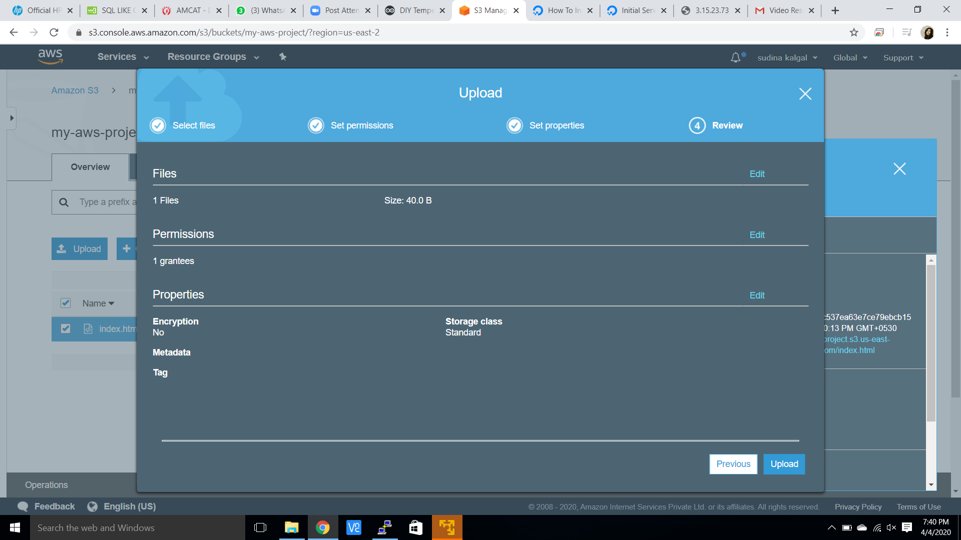

1. **Enabling static website**

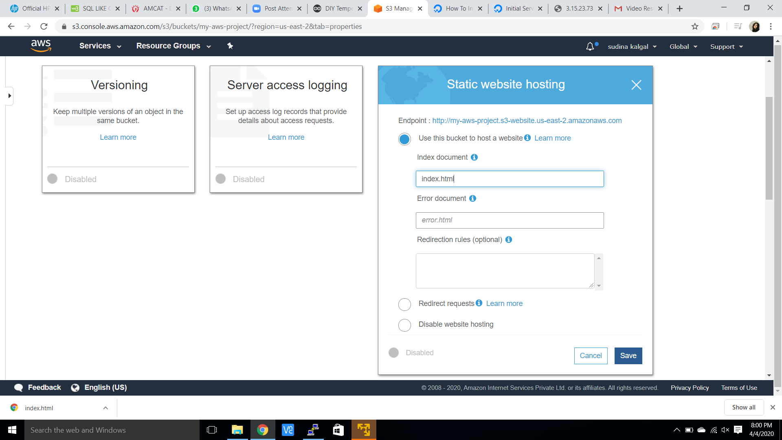

1. **Making object public**

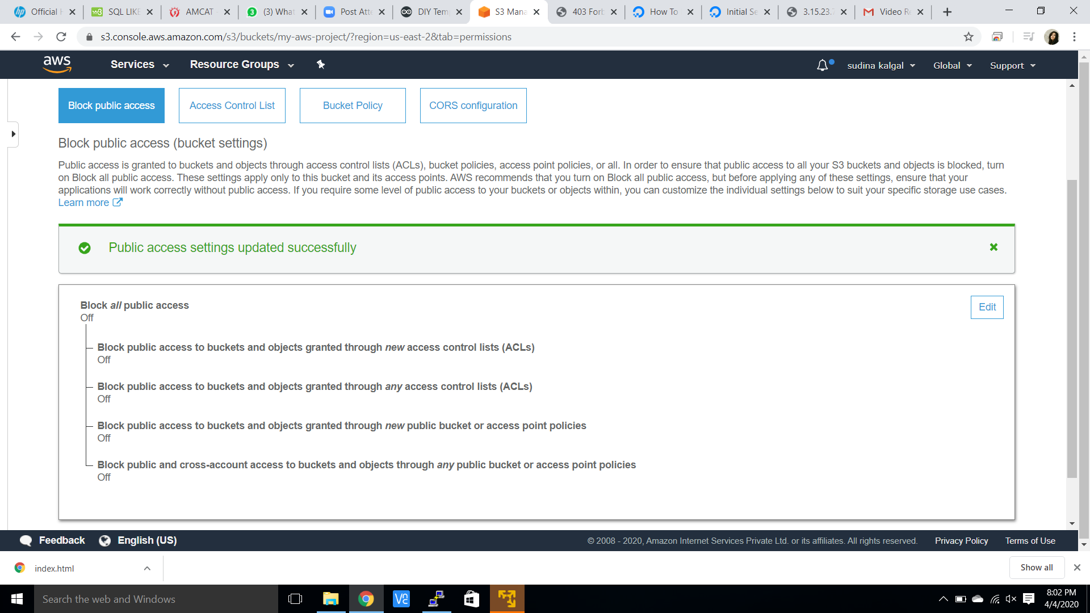

1. **Checking the S3 link on the browser**

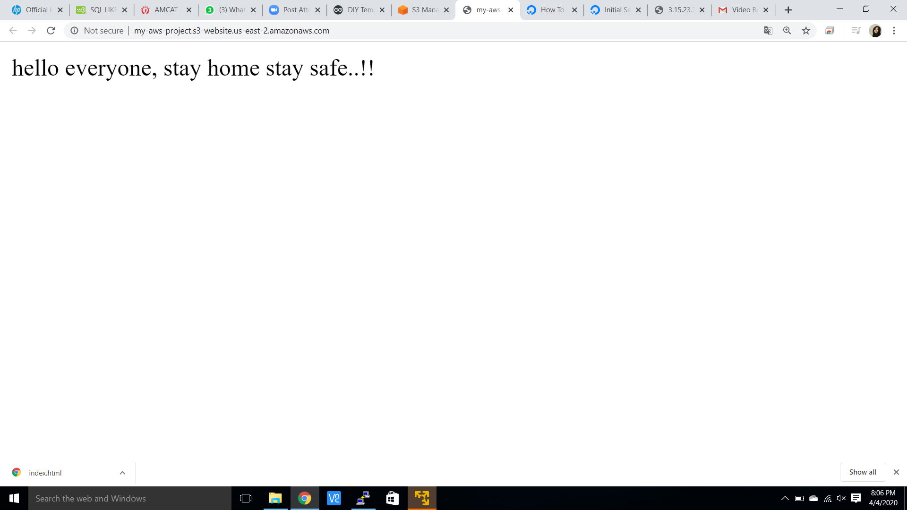

**REKOGNITION SCREENSHOTS:**

1. **Face detect**

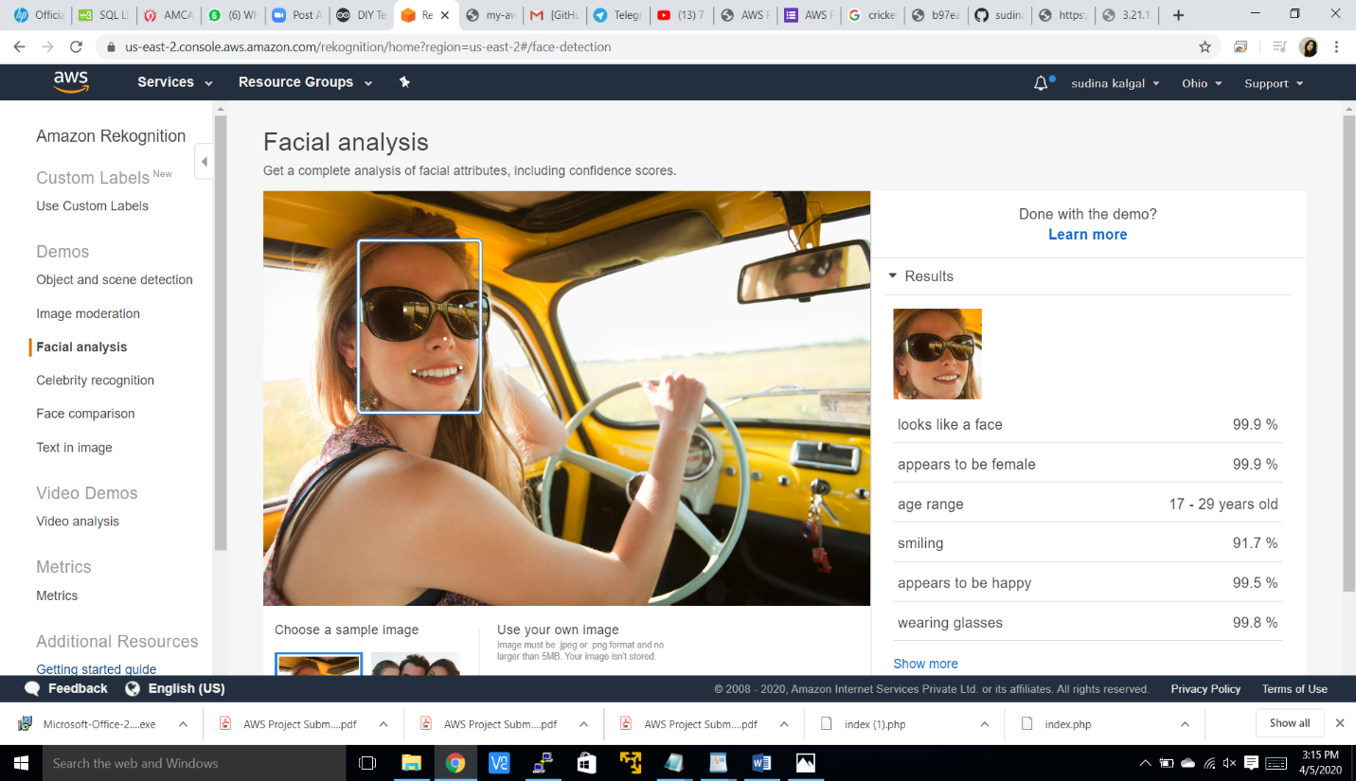

1. **Face compare**

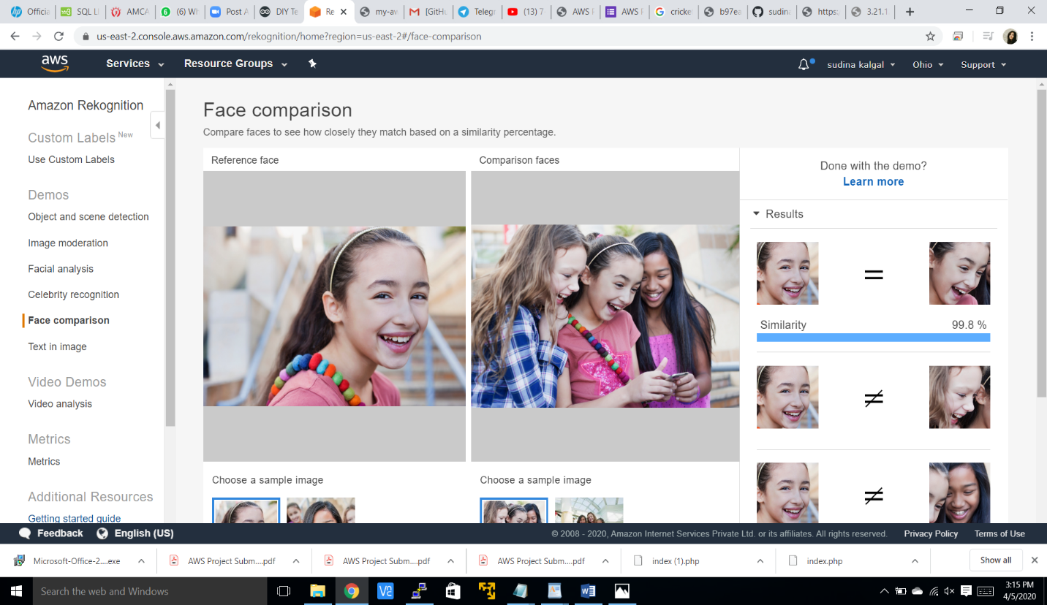

1. **Celebrity recognition**

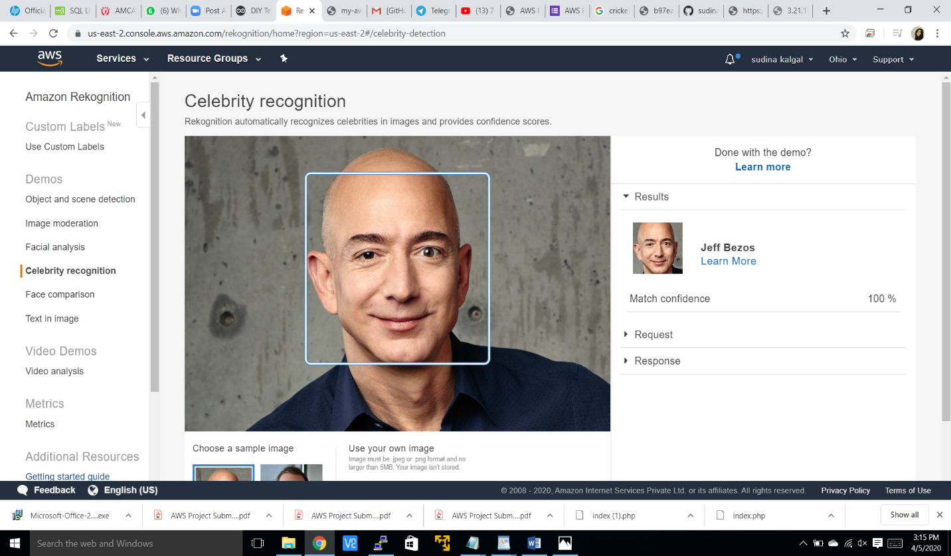

1. **Text in image**

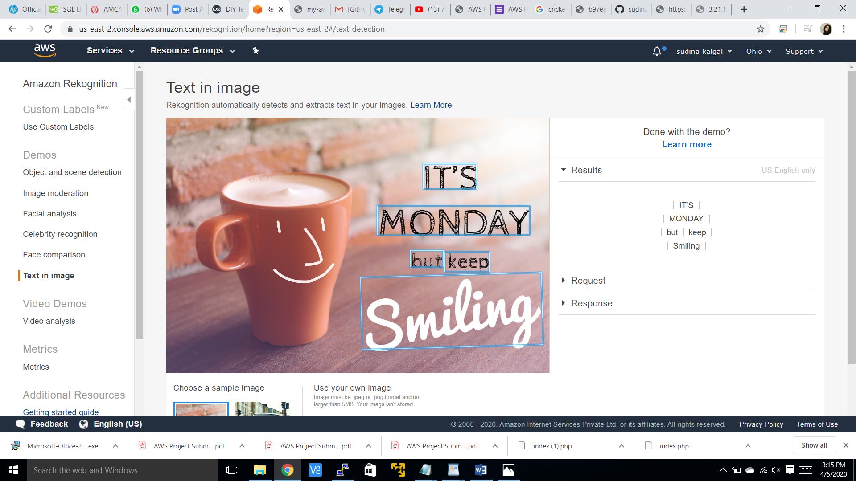

**EC2 AND S3 SCREENSHOT:**

1. **Installing aws-sdk**

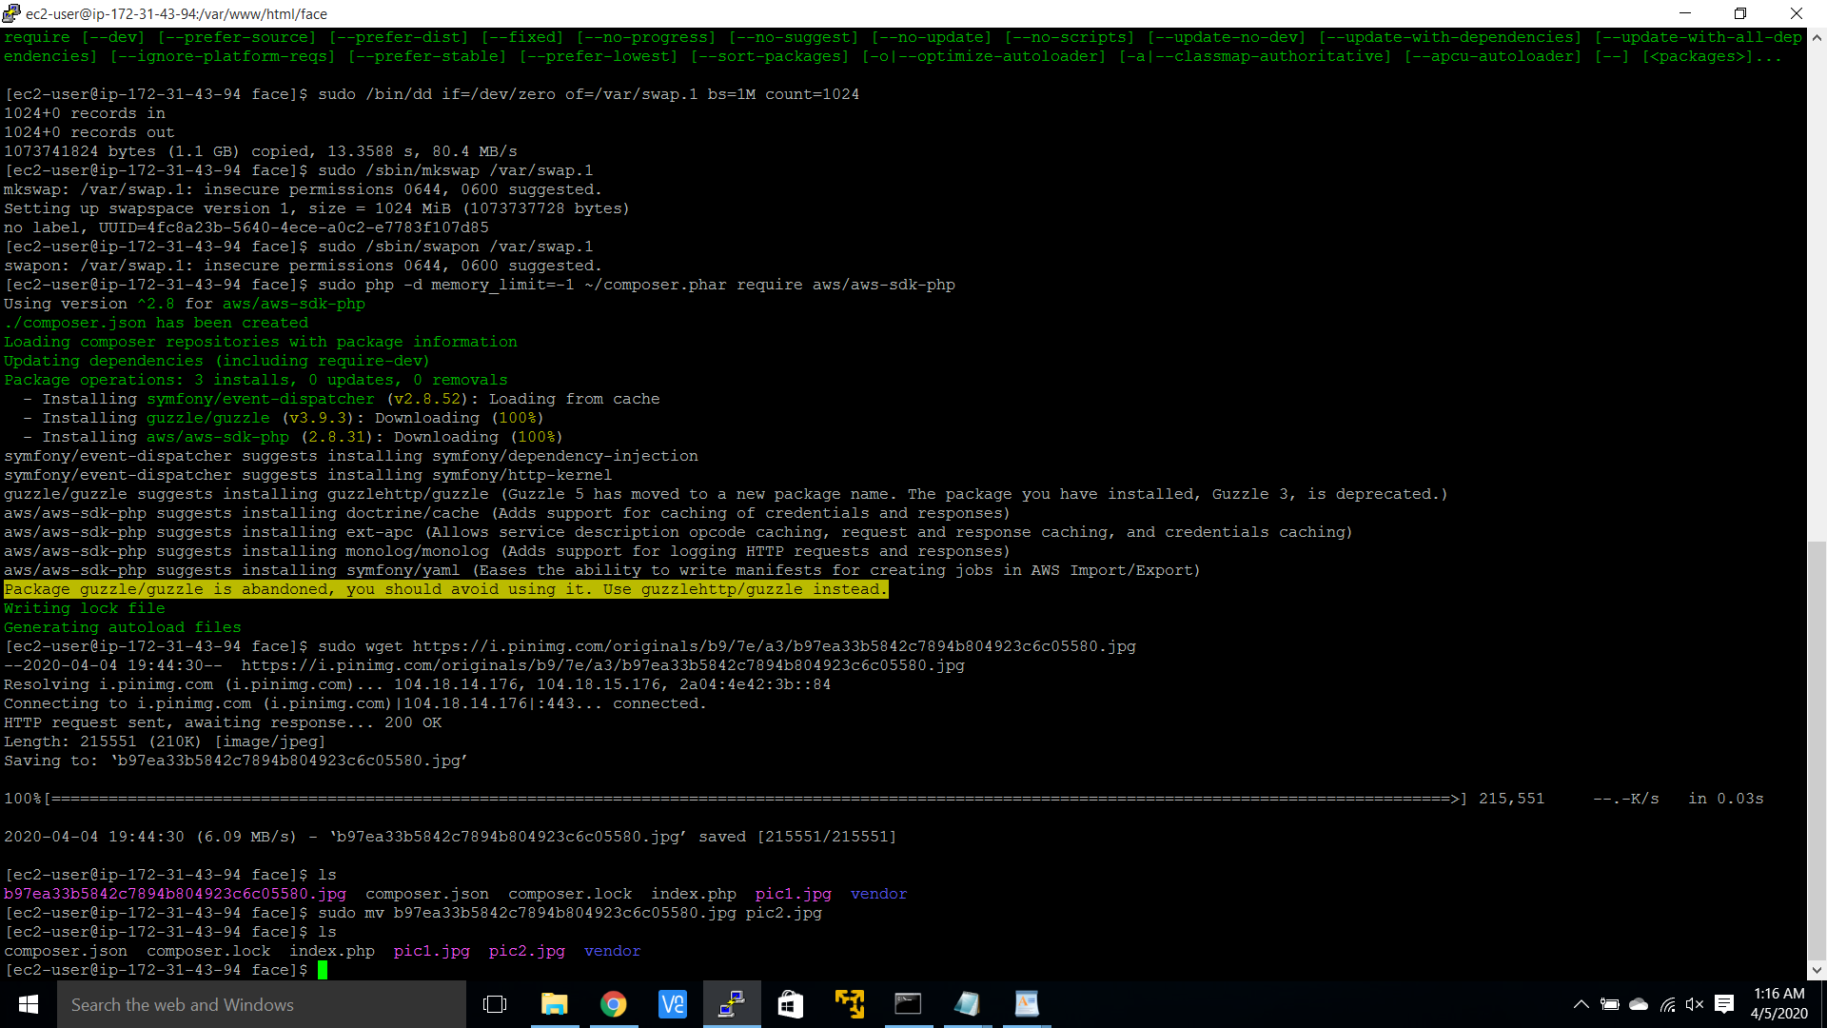

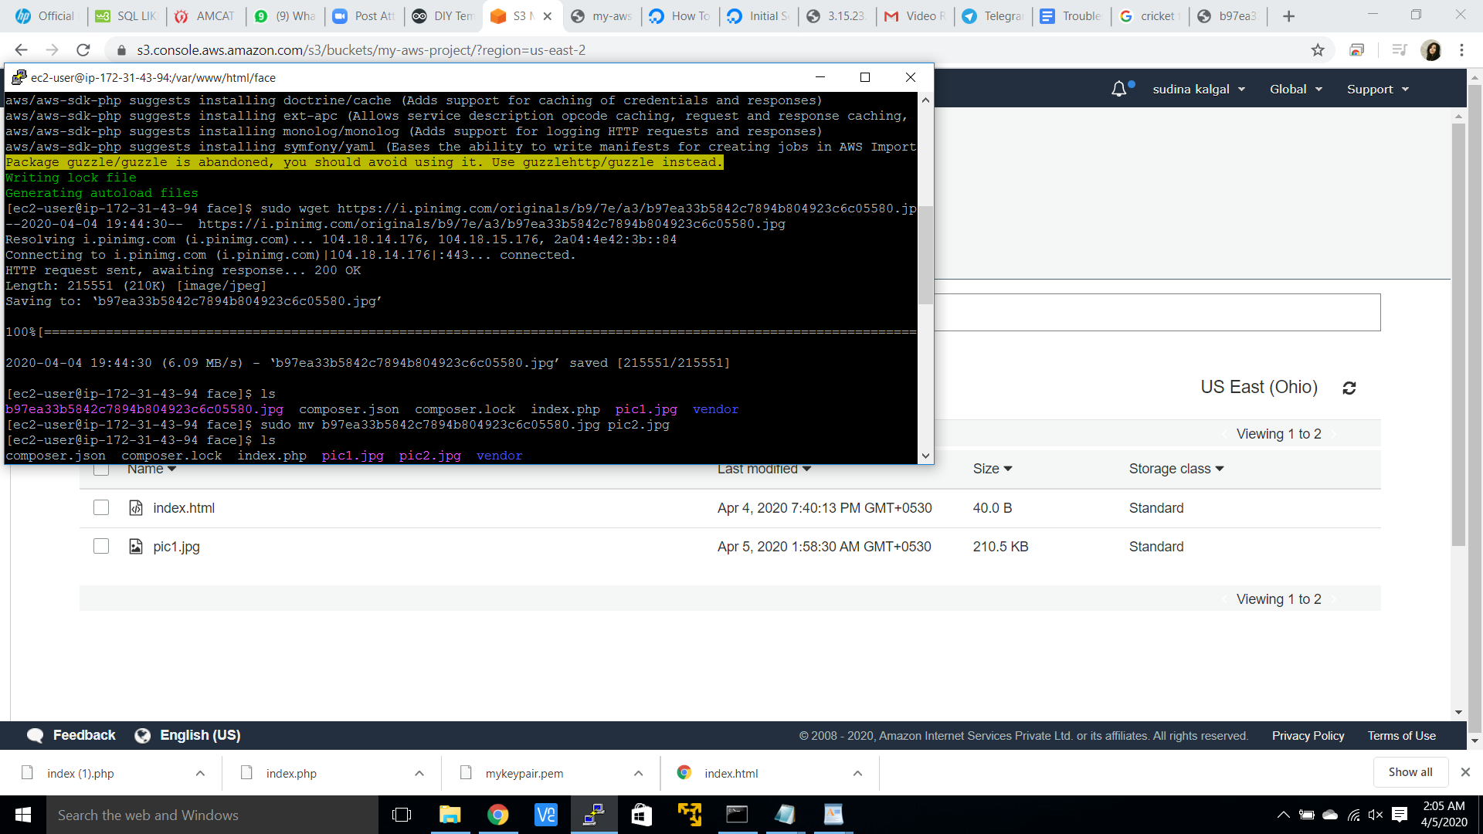

1. **Installing php**

**(I have already installed it before and forgot to take screenshot)**

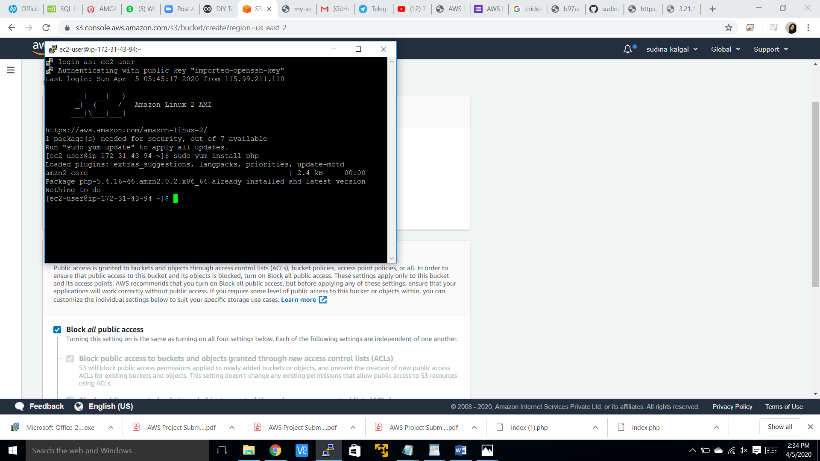

1. **Index.php file code**

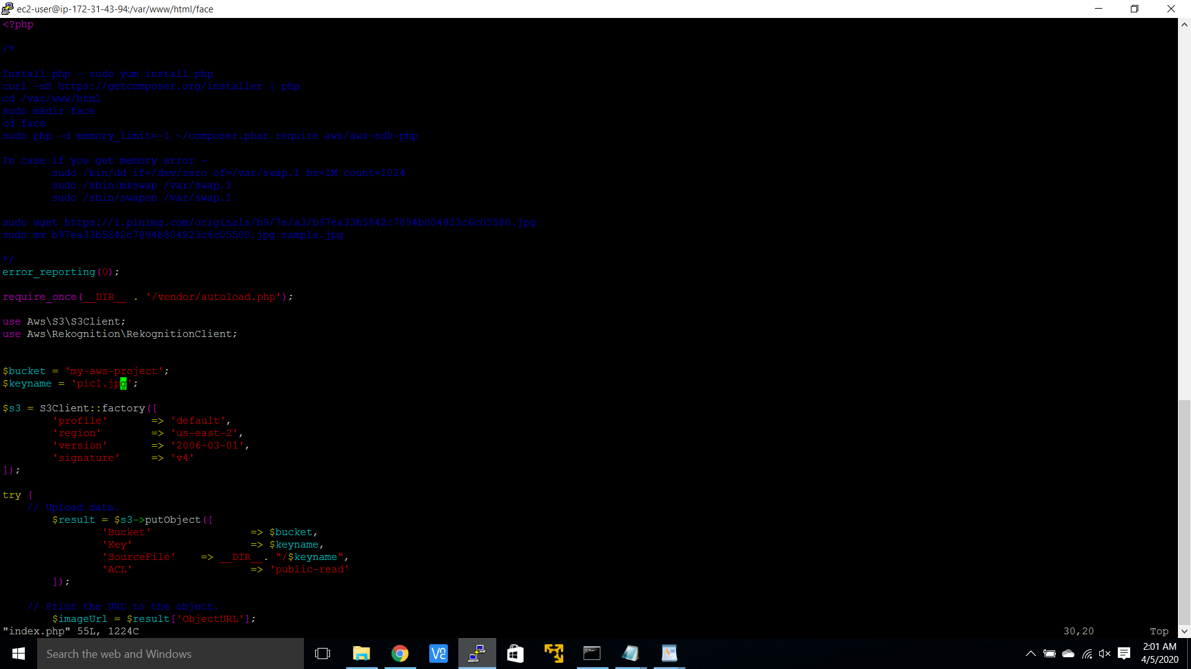

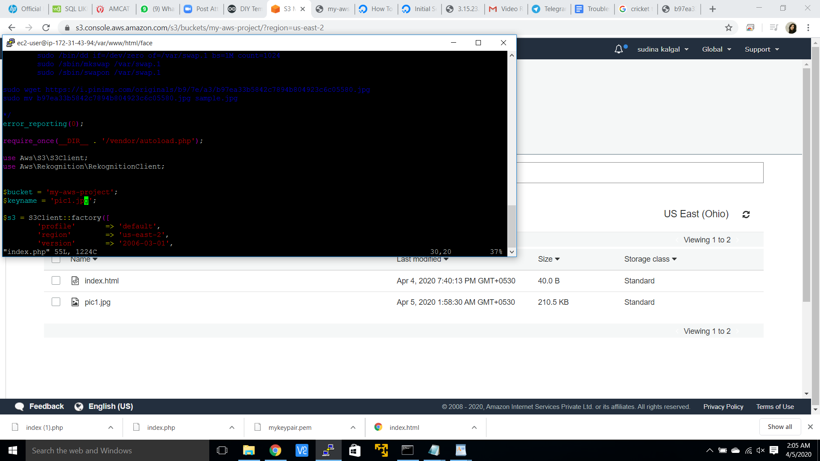

1. **Upload success screenshot**

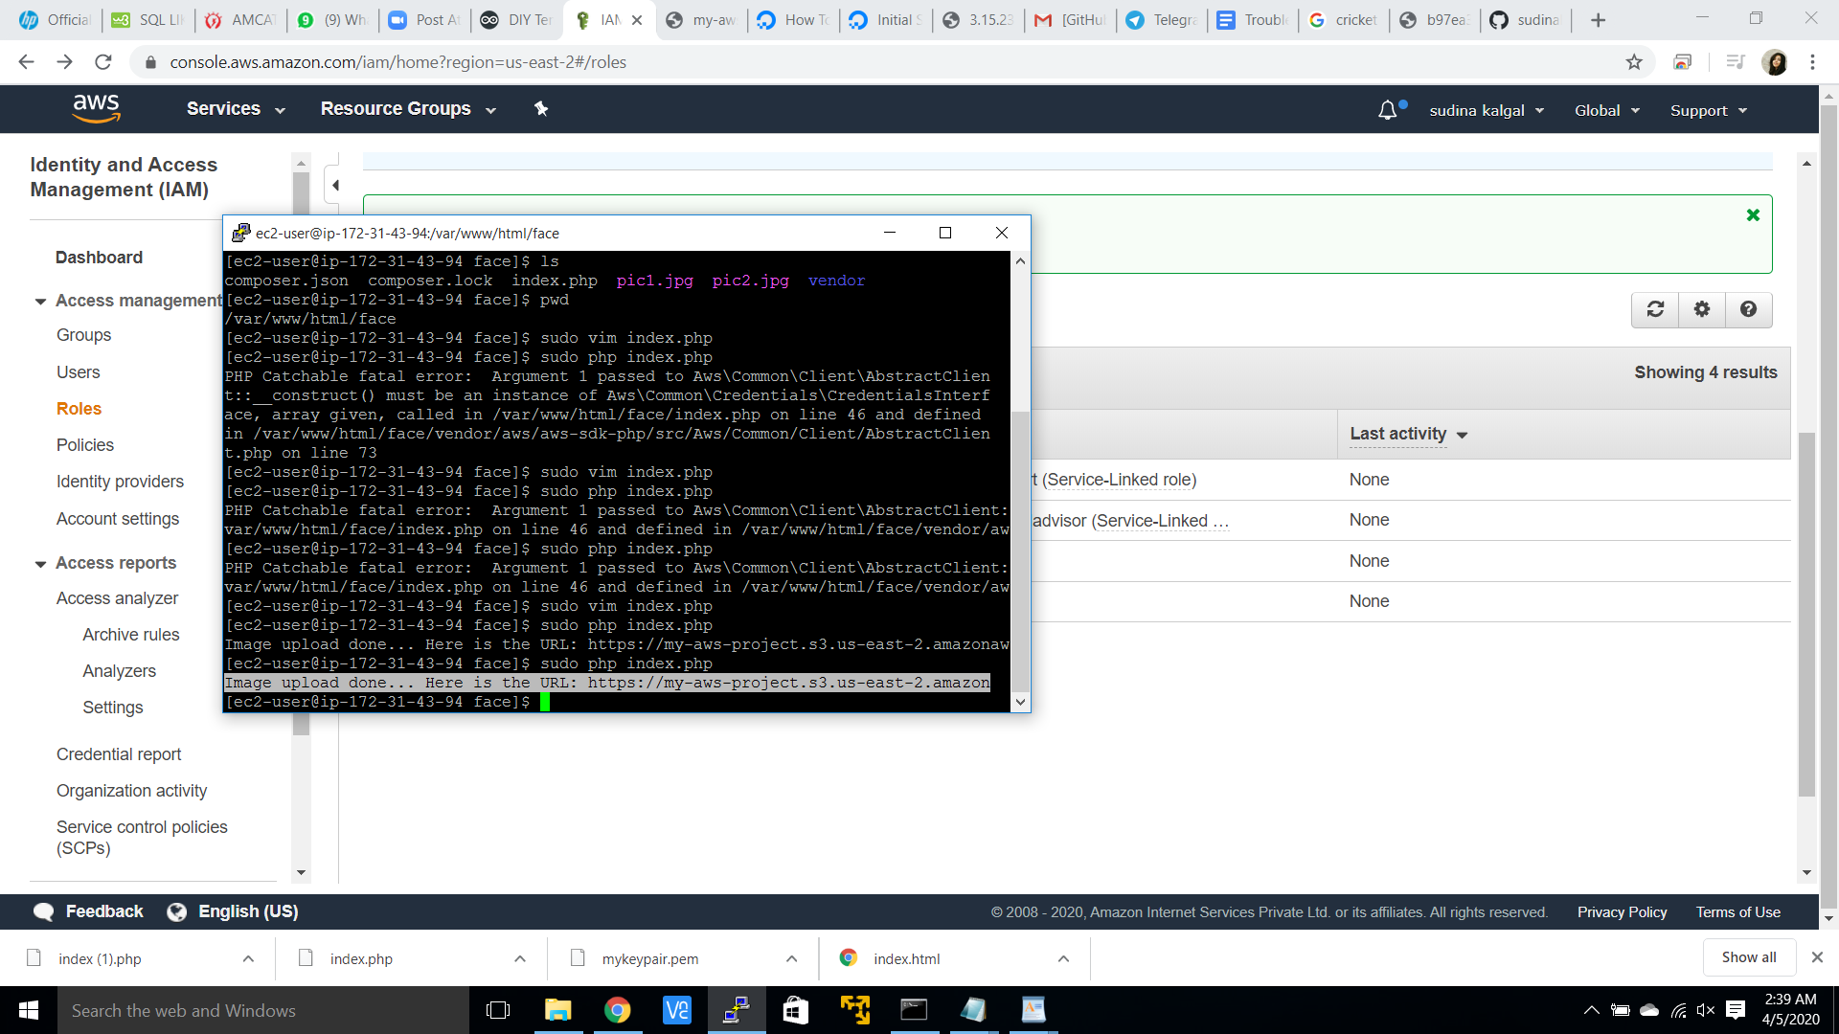

**I got this :-**

